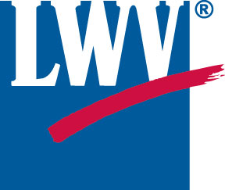
LEAGUE OF WOMEN VOTERS®
[Date]

[Candidate name
Candidate street address
Candidate town, state, zip]
Dear [candidate name],
The League of Women Voters—a nonpartisan organization dedicated to encouraging voting and educating voters—would like to invite you to participate in VOTE411, an online voter’s guide that provides candidate information at all levels, including local, for the 2018 general election.

When voters enter an address on the website (www.vote411.org), they will see information on the candidates running for each office on their ballot, from the top of the ticket down to local council, mayoral and board of education races.

We invite you, as a candidate, to enter biographical information and answer 3 to 5 League-posed questions about your positions. All of this is done online. The League, through VOTE411, will send you an email with a unique link for you to enter your information. The email will come from ted.dellinger@gmail.com with the subject line “Invitation: League of Women Voters VOTE411.”

To get started, we need your email address. Please send the email you would like us to use to send you the link and a phone number where you can be reached to me at [your email address].

If you prefer, or if you have questions, you can also reach me at [your phone number]. I am a VOTE411 volunteer and League of Women Voters member from Monmouth County.

VOTE411 was launched nationally in 2006. Since then, 35 million voters have visited the site. For this election cycle, the League of Women Voters in Monmouth County is working to cover as many local races as possible in a strictly nonpartisan manner. We are promoting VOTE411 through social and traditional media and in all of our contacts with voters.

Hoping to hear from you soon and thank you for running.

[Your name]

